**Working Together in Collaboration and Partnership with Local Stakeholders**

At ISSUP Malaysia, we believe that addressing drug-related concerns in our local communities requires more than just knowledge and resources—it demands strong collaboration and partnership.

We are committed to working hand-in-hand with local stakeholders across sectors to ensure that our efforts in prevention, treatment, and recovery are not only beneficial, but also impactful and sustainable.

Local communities are at the heart of effective drug demand reduction efforts. By building meaningful partnerships with schools, community leaders, healthcare providers, NGOs, law enforcement, and other relevant agencies, we are better positioned to respond to the unique challenges and strengths of each locality.

Through these collaborations, ISSUP Malaysia strives to:  
✔ Strengthen evidence-based prevention initiatives  
✔ Enhance access to quality treatment services  
✔ Support recovery pathways that are community-driven and culturally relevant

We recognize that no single entity can tackle these challenges alone. The success of our efforts relies on a shared vision, open communication, mutual trust, and a commitment to learning and growing together.

*"True partnership is not just about working together—it’s about growing together to create lasting change."*

**Join us.**  
If you’re a local stakeholder, practitioner, or organization passionate about making a difference, we invite you to connect with us. Let’s explore how we can collaborate to build healthier, drug-free communities across Malaysia.

**Together, we can make a lasting impact.**

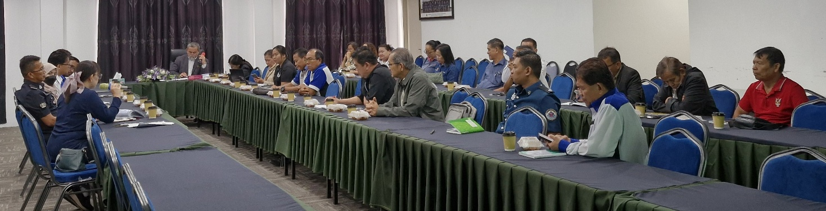

Meeting with One Stop Committee on Drugs and Substance (OSC, Bau, Sarawak)